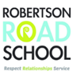

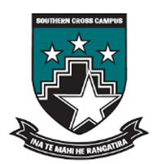

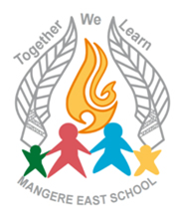

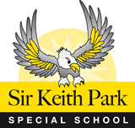

Whakatipu Akoranga - Kāhui Ako

Whakatauki: Tuu kootahi taatou, wehe ka ngaro
Unless you stand together, consider the attempt for success a failure.
Without the community of learning there will be no success.

Whakatipu Akoranga - Kāhui Ako Contents Page
- Te Wai o Hua - Mana Whenua & Kāhui Ako Iwi Partners - page 3

- Whakatipu Akoranga Vision- Mission-Purpose - page 4

- Whakatipu Akoranga Kāhui Ako Context - ERO February 2017 – page 5

- Achievement Challenge Context Writing - page 6

- Achievement Challenge – page 7

- Theory of Improvement Strategic Goal A. Student Agency - page 8

- Theory of Improvement Strategic Goal B. Teaching As Inquiry - page 9

- Theory of Improvement Strategic Goal C. Effective Pedagogy for Valued Outcomes for Diverse Learners - page 10

- Theory of Improvement Strategic Goal D. Strengthening Leadership Capability that focuses on the Leadership Conditions for Improvement - page 11

- Theories of Improvement Reference Materials - page 12

- Whakatipu Akoranga – Kāhui Ako Structure – page 13

- Memorandum of Agreement - pages 14-17

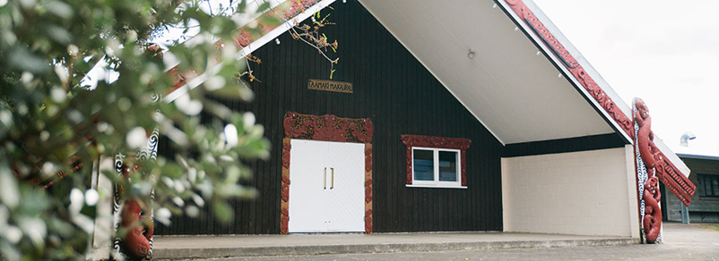
- Appendix 1: Whakatipu Akoranga Kahui Ako Location Map - page 18

- Appendix 2: Framework for Open to Learning Conversations - page 19

- Appendix 3: Framework for Change Leadership / Thinking Processes - page 20

- Appendix 4: Framework for Formative Assessment - page 21

- Appendix 5: Framework for Student Agency Competencies - page 22

- Appendix 6: Kahui Ako Achievement Data 2014-2016 - page 23

Whakatipu Akoranga
Te Wai o Hua - Mana Whenua & Kāhui Ako Iwi Partners

Te Wai-o-Hua - Mana whenua  Makaurau Marae  A kuia’s message to our Kāhui Ako about her aspirations for her mokopuna  - Acknowledge, develop and support their culture, language & identity.  - Understand and support the significance of Tangata Whenua and particularly for my mokopuna the status of Mana whenua.  - Correct pronunciation Maori words and our children’s names.  - Ensure our students’ knowledge of Te Ao Maori.  - Appreciate the value of Matauranga Maori and include it in the curriculum.  - Be aware of Maori theory and philosophies & Tiriti based practice.  - Acknowledge the mana and potential of mokopuna.  - Nurture her wairua.  - Support her to be an active, interested, vibrant learner.  - Be aware that within tikanga we practice ako – the reciprocal process of learning (teacher/child/whānau) and that we learn from each other.  - Embrace the whānau relationship and value any contributions we might make. Be aware that when a Maori speaks, it is not necessary the opinion of all Māori.  - Let her learn in a positive environment where it is a good thing to be Maori. | Te Wai o Hua - Mana whenua & Iwi Partners Makaurau Marae - Waikato Tainui – Kingitanga  Te Wai-o-Hua originate from Te Wakatūwhenua and Te Moekākara canoes, and from the early Hawaiki tribe Ngā Ohomatakamokamo-o-Ohomairangi (Ngā Oho), who once dominated much of the land between Tauranga and Cape Rodney, near Leigh.  Ngā Oho subsequently divided into three groups, based in three areas: Ngā Oho at Papakura; Ngā Riki from Papakura to Ōtāhuhu-Ihumatao and Ngā Iwi from Ōtāhuhu-Ihumatao to the North Shore. Eventually they merged to become Te Wai-o-Hua (the waters of Hua) under the chief Te Hua-o-kaiwaka.  Te Wai o Hua Rangatira  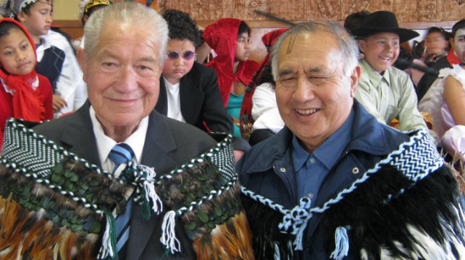  The Late Maurice Wilson QSM & The Late Joe (Jones) Matata  Consultation on the intentions/outcomes of the achievement plan has taken place, which had a particular focus on the educational success for all Māori students. The following commitments have been confirmed and the intentions of points 1-6 will be included/integrated into the goals of each annual plan.  - That Te Wai o Hui are our Iwi partners and our marae is Makaurau Marae  - To strengthen relationships and a sense of belonging with our Iwi across our Kahui Ako  - That Te Wai o Hua have a place in the Kahui Ako Governance Group  - To strengthen all Kahui Ako members understandings of the Maori world view through the lens of mana whenua.  - That through this Iwi relationship, all Kāhui Ako members strengthen their knowledge, understanding and experiences of historical and current happenings in the whenua  - That we want all Māori students to have success in our Kāhui Ako as Maori  Our Kāhui Ako wishes to acknowledge the gifting of our name by Te Wai o Hua.  Whakatipu Akoranga – Growing Together  Whakatauki: Tuu kootahi taatou, wehe ka ngaro: Unless you stand together, consider the attempt for success a failure. Without the community of learning there will be no success.

Whakatipu Akoranga Kāhui Ako Vision- Mission-Purpose
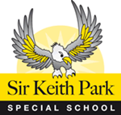

Vision | Mission | Purpose | Strategic Goals
We want every student in our Kāhui Ako to:  - Be strong in their national and cultural identity.  - Aspire for themselves.  - Have the choice and opportunity to be the best they can be.  - Be an active participant and citizen in creating a strong society.  - Be productive, valued and competitive in the world. | Our mission is to nurture, grow, and accelerate learning within our culturally rich and diverse community.  Through an active partnership with our whānau and community we will move forward with courage and commitment to share knowledge, expertise and strengths.  Our aim is to develop curious, thoughtful, confident and reflective learners who are respectful citizens of the 21st Century. | Our purpose is to collaboratively inquire into the impact of teaching and learning practices on student achievement and to share strengths, expertise and knowledge.  We are deliberately collaborating to grow a progressive mind-set and develop a capability to be responsive to the needs of our learners in order to accelerate their learning.  There will be an explicit focus on building student agency to develop curiosity, thoughtfulness, ownership and reflection.  This growth in student agency will empower our students to make informed choices and maximise clear access to the growing opportunities in Mangere, the wider society and the competitive world they live in. | Our overall achievement challenge is to raise writing across the COL so that 85% of our students are at or above the appropriate standards or curriculum level by 2020. We believe that accelerating students’ achievement in writing will support our goal of 85% of our Year 13 students achieving Level 3 by 2020 and 50% gaining University Entrance.  To achieve our achievement challenges, we identified four overarching strategic goals that will enable us to support our vision, mission and purpose. These strategic goals focus on:  - Student Agency  - Teaching as Inquiry  - Cultural Responsiveness & Engagement  - Building Leadership Capacity
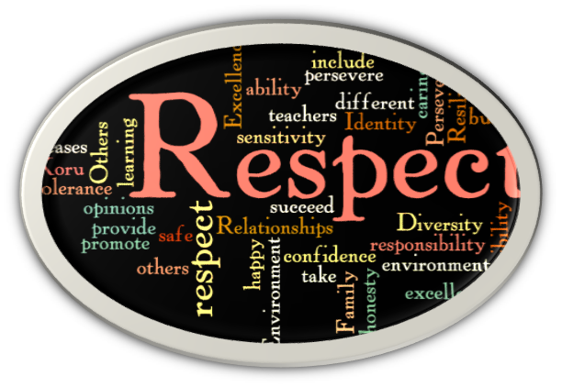
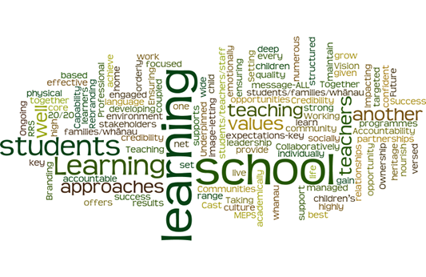

Whakatipu Akoranga Kāhui Ako Context - ERO February 2017

Whakatipu Akoranga comprises five schools. One of these is a composite school (Years 1 to 15) and there are four full primary schools (Years 1 to 8). A feature of the Kāhui Ako is that learners have few transitions to make between schools. Children and young people at one of the five schools are able to remain at that school for all of their schooling and in the other four schools’ they only have to make the transition at Year 8 to secondary school. Good quality practices and strengths within our Kāhui Ako include:
- developing leaders and teachers' capability to collate, analyse and use achievement data to improve student outcomes
- evaluating the effectiveness of assessment tools and processes
- monitoring and tracking student progress school-wide
- setting relevant learning goals with parents and whānau
- sharing achievement information with students to help them talk about and review their learning
- strategic targets that are aimed at reducing achievement disparity between boys and girls and between different ethnicities
- scheduling time for teachers to evaluate student achievement, particularly for those learners who require accelerated progress
- personalising teaching strategies to respond to each student’s learning requirements
- achievement information is being used well by school leaders to identify school priorities
- a commitment within schools to the collective responsibility of raising student achievement that is supported by relevant professional learning and development (PLD)
- targeted support for students who are at risk of not achieving
- overall student achievement improving over time
- inclusive school environments that are characterised by respectful relationships
The following next steps as identified by ERO are underpinned by the theories of improvement outlined on pages 8-12 of this document. These are;
- further raising student achievement, particularly for boys, Māori and Pacific students using collaborative spiral of inquiry
- strengthening staff capability in collating, analysing and using achievement information with a focus on accelerating student progress
- including parents and whānau as partners in their children's learning
- supporting students to have more ownership of their learning
- evaluating how well each school's curriculum responds to and builds on students' language, culture and identity
Whakatipu Akoranga Kāhui Ako - Achievement Challenge Context Overview - Writing
Literacy is the ability to read, view, write, design, speak and listen in a way that allows us to communicate effectively. The power of literacy lies not just in the ability to read and write, but rather in a person’s capacity to apply these skills to effectively connect, interpret and discern the intricacies of the world in which we live.
Our collated Kāhui Ako data revealed that writing was the lowest performing area (59.2% at or above) and so we have this as our achievement challenge focus.
Within this curriculum focus there is a sub focus on boys’ underachievement. In our Kāhui Ako there is an 18.5% disparity in achievement in writing between the boys (49.7%) and girls (31.2%).
Underpinning our commitment to raise student achievement in writing our four theories of improvement that once embedded will strengthen teaching and learning programmes across the curriculum. These powerful theories will enable teachers to strengthen (a) Student Agency
(b) Teaching as Inquiry (c) Cultural Responsiveness & Engagement for Diverse Learners and (d) Building Leadership Capacity which will (through known research) lead to greater numbers of priority learning reaching and/or exceeding their relevant standards as well as building their capacity to be successful lifelong learners.

Overall Achievement Challenge Goal
By 2020 85% of students in Year 13 will achieve NCEA Level 3

Year 1-8 National Standards Achievement Challenge
- By 2020, 85% of students in Years 1-8 will achieve at the National Standard in Writing. This equates to an additional 718 students shifting from Below to At or Above the National Standards, a 25.8% percentage point shift.
- By 2020 85% of students from years 1-8 will achieve at or above the National Standard in Mathematics. This equates to an additional 662 students shifting from Below to At or Above the National Standard, a 24% percentage point shift.
Achievement of students with ORS verification working pre or within Level One Long term
In 2017 there are 166 students with ORS verification enrolled in the Whakatipu Akoranga Kāhui Ako
- Individual students will have a baseline assessment using an online tool designed to be able to detect the subtle improvements achieved by ORS verified students in order to identify and record even the smallest of achievements.
- Individual students will make 5% progress annually measured using the assessment programme B Squared. Variations will inform action plans for teaching and learning
166 = sum of 157 (SKP) + 4 (Sutton Park) + 4 (Southern Cross) + 0 (Robertson Road) + 0 (Mangere East) + 1 (Koru)
Achievement Challenge Years 9-10
- By 2020, 80% of students in Year 9 and 10 will be achieving at the expected curriculum level in writing. This equates to an additional 125 students shifting from Below the expected level to At or Above the expected Level, a 38% percentage point shift.
Achievement Challenge Year 13
- By 2020, 85% of students in Year 13 will be achieving at NCEA Level 3.This equates to an additional 27 students achieving Level 3.
- By 2020, 40% of students in Year 13 will achieve University Entrance. This is an additional 31 students achieving University Entrance.

Te Wai-o-Hua - Mana Whenua  Makaurau Marae  Whakatipu Akoranga Achievement Challenge  Tama & Ezra’s message to their Teacher  - Teacher Collaboration/Prior Knowledge: Please speak with my teacher from last year and find out from him/her what I’m really good at with my learning and then build on this when I’m in your class this year.  - Teaching as Inquiry: When I get stuck with my learning, ask other teachers for ideas on how to help me overcome the learning goals I’m stuck with so that I can meet and/or exceed all of my learning goals.  - Home/School Partnerships: Please keep in touch with my family/whānau regularly and share with them (a) what is going well with my learning and (b) ways they can help with my learning goals at home  - Formative Assessment: Please give me regular feedback and feed forward on my learning goals both orally and written in my books using words/language I understand.  - Accelerated Learning: When you notice that I am stuck with my learning goals, please find some time to give me extra help.  - Student Voice: Each day, please ask me:  - how could you, as my teacher, have helped me to become a better learner today?  - were the learning tasks set for me, too hard, too easy or just right?  - what made learning fun/interesting today? | 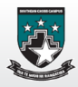  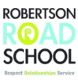  Personalised earning pathways for students in Kāhui Ako - Communities of Learning 2017 - 2020
Achievement Challenge
To accelerate the achievement levels of students, through embedding effective teaching practices, building greater levels of student agency, further strengthening whānau engagement and ensuring a culturally responsive curriculum is delivered.

Year 1-8 National Standards Achievement Challenge

- In 2016 1644/2778 or 59.2% students of our students were At or Above the National Standard in writing for Years 1 to 8. By 2020 we will lift this to 85% 2362/2778. This will mean shifting a total of 718 students overall.
  - Within our overall goal of shifting 718 additional students there is a sub goal for boys: We aim to lift the achievement of all boys in writing from 50% (728/1448) to 85% (1231/1448) by the end of 2020. This is a total shift of 503 or more boys from Below to At or Above the standard in writing.

- In 2016 1700/2778 or 61.2% of our students were At or Above the National Standard in mathematics for Years 1 to 8. By 2020 we will lift this to 85% 2362/2778, a 24.5 percentage point shift. This will mean shifting 662 additional students from Below to At or Above the National Standards.

- In 2017 there were 166 students with ORS verification enrolled in the Whakatipu Akoranga Kāhui Ako. Students will make an average 5% progress annually measured using the assessment programme B Squared.
  - Sir Keith Park School is a special school for children and young people who have intellectual disabilities or complex special needs. All students are working long term within level 1 of the curriculum, and therefore they have been excluded from the National Standards data. Sir Keith Park School will report and measure progress separately using the assessment programme B Squared (Individual Education Plans).

Year 9 and 10 Achievement Challenge
By focussing on writing in years 9 and 10, and making the strategy consistent from years 1-10, we will impact on successful outcomes in all curriculum areas and enhance students’ achievement in NCEA literacy, UE literacy and ensure success in chosen academic and vocational pathways. We will have an ongoing focus on accelerating Māori students’ achievement.

- In 2016, 42% (138/330) of our Year 9-10 students were working within or above the expected curriculum level in writing. By 2020, we will lift this to 80% (263/330). This will mean shifting a total of 125 students overall.

Year 13 Achievement Challenges: Our target for Year 13 is 85% Level 3 NCEA by 2020 plus a target for UE. Level 3 gives students access to courses that enable them to progress to a higher qualification and acknowledges our fundamental belief that students in our community should achieve at levels expected in more affluent areas. This will make them more likely to succeed in their chosen pathway.

- In 2016, 68% (107/158) of our year 13 students achieved level 3 NCEA. By 2020, we will lift this to 85% (134/158). This will mean moving 27 additional students overall.
  - Māori sub target: We aim to increase the number of Maori students achieving NCEA Level 3 by 15% over the four years.

- UE: In 2016, 20% (32/158) of our Year 13 students achieved UE. By 2020, we will lift this to 40% (63/158) by 2020. This will mean an additional 31 students achieve UE.
  - Māori sub target: We aim to increase the number of Maori students achieving UE by 15% over the four years.
  - We aim to improve the NCEA endorsement rates for Level 3 by 15% over 4 years for students who have chosen to study at least 4 ‘01’ subjects. (These subjects make up the Southern Cross Campus pathway to University courses and are required for the UE qualification).

Te Wai-o-Hua - Mana Whenua  Makaurau Mara  Whakatipu Akoranga  Theory of Improvement  Strategic Goal A. Student Agency  Background Understandings:  Student agency refers to the level of control, autonomy and power that a student experiences in an educational situation.  Student agency can be manifested in the choice of learning environment, subject matter, approach, and/or pace.  Student agency is most evident when teachers provide the right environment, support and approaches to learning that enable all learners to develop the skills and attitudes for agency to occur.  Student agency is also about each student being engaged in, and empowered to take responsibility of their learning through reflection, goal setting and a range of other self-monitoring behaviours.  Students will gain the skills and confidence to navigate their learning responsibilities more independently and will transfer responsibility for their learning from the teacher to themselves.  Strengthening student agency involves three key areas:  - sharing the development and maintenance of learning environments  - sharing the locus of control between teacher and students  - involving parents and whānau in student learning.  Student Agency has alignment with growth mindset, in that educators believe that students’ most basic abilities can be developed through dedication and hard work—brains and talent are just the starting point. This view creates a love of learning and a resilience that is essential for great accomplishment. | 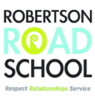  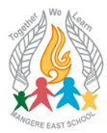  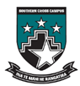  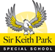  Personalised learning pathways for students in Kāhui Ako - Communities of Learning
 | Aim: To deliberatively increase levels of student agency of all students, especially boys’ agency, by supporting teachers to introduce and/or build on existing effective strategies.
 | Establishing - 2017 |  | Developing - 2018 |  | Embedding - 2019 |  | Fully Functioning - 2020
 | - Use a collated PMI from across all Kāhui Ako classrooms that will provide evidence of the current level of student agency in writing programmes, then based on the evidence collated, plan next steps in strengthening student agency.  - Collect student voice from across Kāhui Ako classrooms to seek their views on ways their teachers can strengthen learning focused relationships and action their responses, accordingly.  - Unpack the six Assessment for Learning teacher capabilities to gain shared understandings amongst Kāhui AKo schools. Teachers to self-assess where they are on the capability matrices and identify ways of strengthening teacher practices against these matrices in Term 3 & 4, particularly focusing on the locus of control descriptors. Keep the Assessment for Learning capabilities as an ongoing self-assessment document.  - All teachers to co-construct ways students will provide them with daily, weekly and termly feedback as to whether the teaching strategies trialled are leading to improved agency and respond accordingly.  - Teachers deliberately plan to support, model and teach growth mindset so students can learn and demonstrate agency. For example care, confer, captivate, clarify, consolidate, challenge and  self-management. |  | - Using Assessment for Learning (AFL) Teacher Capability 1. Building Learning-focused Relationships, teachers prioritise the goals they will be working on and present evidence of shift in their practice to their team leader by the end of each term.  - Trial student / family / whānau writers’ workshops that focus on recording favourite stories, tales, myths and legends heard within one’s whānau/community. Writers to choose the form/style they want to present their writing in and present it to their audience of choice.  - Across and within school leaders’ work alongside teachers in the targeted cohort groups to support them as they strengthen their teaching goals that builds student agency. (Refer to AFL Matrices).  - With permission, an online portal is created so that resources/ideas can be uploaded to the web page that teachers can then share with each other their stories/evidence of how student agency is being strengthened in the writing programmes for our targeted boys’ cohorts.  - All teachers have an inquiry goal that directly links to building their capacity to strengthen student agency in classrooms, particularly classrooms of our targeted boys. Goals are identified via the Assessment for Learning matrices and Student Agency Competencies Table. |  | - Implement the AFL Teacher and Student Matrices and Student Agency Competencies in all classrooms.  - Students, particularly our targeted boys, are regularly publishing work via: on line blogs, in print and in audio forms. Once a year these boys will have work printed in book form that will be presented to each school, to be placed in their library and one copy of the student’s family/whānau. For student learning in bilingual pathways, these books will be printed in both their first / heritage language and English.  - Consider the options of an across Kāhui Ako digital platform that would be actively used in supporting learning by all teachers, students and parents / whānau.  - the schools with teachers supporting each other with on-line teaching strategies  - Establish a student writers / reporters club / publishing team from the Kāhui Ako identified targeted cohort. This team will have the responsibility of producing a Kāhui Ako student newspaper twice a year.  - Students articulate the skills they are using that promote strong agency in writing.  - Majority of boys in classrooms in our targeted cohorts (Year 2, 4, 8, & 10) exhibit high levels of agency in their writing programmes. This will be evidenced through teaching practices and adaptive learning environments that allow boys to display high levels of choice over their subject matter, learning environment, approach and/or pace of their learning. |  | - Through the outcomes of teacher inquiry cycles, present evidence of how they have successfully implemented the AFL & Student Agency capabilities and what effect these have had in lifting student achievement.  - Teachers can describe (with evidence) the strategies they use that builds student agency into all teaching programmes.  - Each school will identify annual goals focused on the ongoing embedding of student agency in targeted classrooms. Progress reports are completed by teachers at the end of each term and then discussed with team/Kāhui Ako leaders.  - Students play a more meaningful role in deciding what to learn and how to learn it and this will be reflected in schools curriculum programme overviews.  - Students are confident, resilient, active, self-regulating learners across the curriculum and can describe what their learning goals are, how they monitor their progress towards them and the corrective strategies they use when they see their rate of progress falling.  - All teachers have inquiry goals that build their capacity to strengthen student agency across the curriculum.
Te Wai-o-Hua - Mana Whenua  Makaurau Marae  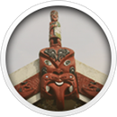  Whakatipu Akoranga - Theory of Improvement  Strategic Goal B. Teaching As Inquiry  Background Understandings:  The fundamental purpose of the Teaching as Inquiry cycle is to achieve improved outcomes for all students. Less obviously, but very importantly, the cycle is an organising framework that teachers can use to help them learn from their practice and build greater knowledge.  Within the teaching inquiry cycle, teachers select teaching strategies that will support their students to achieve their learning outcomes. This involves asking questions about how well current strategies are working and whether others might be more successful.  Teachers search their own and their colleagues’ past practice for strategies that may be more effective, and they also look in the research literature to see what has worked in other contexts.  Teachers also seek evidence that their selected strategies really have worked for other students, and that they set up processes for capturing evidence about whether the strategies are working for their own students.  The learning inquiry takes place both during and after teaching as teachers monitor their students’ progress towards the identified outcomes and reflect on what this tells them. Teachers use this new information to decide what to do next to ensure continued improvement in student achievement and in their own practice.  Although teachers can work in this way independently, it is more effective when teachers support one another in their inquiries. Teachers all hold basic beliefs and assumptions that guide their thinking and behaviour but of which they may be unaware. Working collaboratively with others provides the teacher with different perspectives and a forum to share their ideas, knowledge, and experiences. |  | 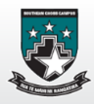  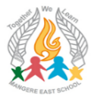  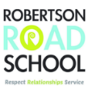  Personalised learning pathways for students in Kāhui Ako - Communities of Learning
 |  | Aim: To raise the achievement levels for all students by building teachers’ capacity to implement sustained effective practice using inquiry and digital tools as key transformation levers.
 |  | Establishing - 2017 |  | Developing - 2018 |  | Embedding - 2019 | Fully Functioning - 2020
 |  | - Review teaching as inquiry models currently in place across Kāhui Ako schools and identify common understandings and practices that underpin such models.  - Kāhui Ako leaders to lead workshops for teachers based on ‘A Framework for Transforming Learning in Schools: Innovation and the Spiral of Inquiry’, by Timperley, Kaser & Halbert 2014 and present a workshop that explores similarities and differences that exist between our current school models and this ‘Spiral of Inquiry’ model.  Develop an agreed model of ‘Teaching as Inquiry’ for our Kāhui Ako schools that focuses on lifting achievement in boys writing through using spirals of inquiry.  Based on December data, all teachers to have agreed inquiry goals in place before the start of Term 1 2018.  - Build collaborative inquiry that is focused on strengthening teaching practice and learning outcomes for all students, involves the learner and their family / whānau, develops hunches that are tested, takes action on new learning / understandings and asks if we have made enough difference before setting next steps. |  | Leaders to work collaboratively with teachers of our targeted boys in:  - scoping their focus for inquiry on lifting achievement levels for boys in writing.  - describing teaching strategies they will use to lift the achievement of boys in writing, particularly linking such strategies to increased student agency.  - monitoring and keeping reflections/evidence on the effect the teaching strategies had in increasing student agency resulting in lifting the achievement of boys in their writing programmes.  - use of student voice within and at the completion of writing modules and acting on this feedback when planning future writing modules with the outcome being strengthening student agency.  - Leaders and teachers to focus their inquiry that explores hunches they hold about what makes great boys’ writers and establish action plans and ongoing evaluations(with strong evidence) in response to those planned actions.  - Leaders and teachers in our targeted cohort Year groups to collect student voice that articulates the approaches / strategies teachers used that enabled them to have success with their writing learning goals. These student stories (with permission) to be celebrated/published on our Kāhui Ako web site.  - Conduct an inquiry into the accelerated learning achieved through mathematics PLDs experienced in the schools in 2017. Use the findings to draft up an agreed approach for accelerating Mathematics achievement in 2018  - Begin collecting moderated samples in mathematics for years 1-8  - Leaders to work collaboratively with teachers of selected cohorts to implement the inquiry model in mathematics. |  | - Teachers use our agreed teaching as inquiry framework as they tailor their practice as the framework through which they tailor their practice to meet the needs of boys through acceleration programmes across the curriculum.  - All teachers open up their learning environments for other teachers in our Kāhui Ako to come and observe, sit alongside students as they learn, and see the adaptive teaching strategies in place that enable our targeted boys to achieve greater levels of success/agency with their learning goals.  - All schools will have a Kāhui Ako document that succinctly outlines the principles and practices that underpin our tailored approach to delivering accelerated programmes that includes building student agency.  This document will be reviewed every 24 months so that it always reflects current effective practices in the area of what makes boys great writers.  Develop an on-line digital platform for mathematics with guidelines, teaching strategies that have been proven to work and annotated samples of work to support consistent and proven approaches to teaching mathematics across the kāhui ako | - Leaders run annual (or as required) ‘Teaching as Inquiry’ workshops for new teachers to our schools.  - Each school sets annual goals that identify teaching practices that focus on what makes boys great writers and reviews the effectiveness of these goals (with evidence), within an ongoing review cycle.  - Student voice will be regularly collected, seeking student opinions on how effectively teaching strategies are working for them as they work to reaching / exceeding their learning goals. This feedback is then used when setting ongoing teaching goals.  - It will be common practice in all Kāhui Ako classrooms to see teaching as Inquiry goals in play. It will be understood by teachers that small changes will create the confidence to design and implement more radical transformational change, which will be needed in order to align teaching to the needs of the students.  Teaching as Inquiry will be the vehicle through which this teacher transformation will take place that aims to lift the achievement levels of boys in writing with urgency.

Te Wai-o-Hua - Mana Whenua  Makaurau Marae  Whakatipu Akoranga Theory of Improvement  Strategic Goal C. Increasing cultural responsiveness by teachers and developing effective pedagogy for valued outcomes for diverse learners.  Background Understandings:  Cultural competence, in terms of teaching, is to affirm and validate the culture/s of each learner. It acknowledges that all learners and teachers come to the classroom as culturally located individuals and that all interactions and learning are culturally defined.  Culture can be described in terms of both its visible and invisible elements: The visible are the signs, images and iconography that are immediately recognizable as representing cultures and that theoretically creates an appropriate context for learning.  The invisible are the values, morals, modes of communication and decision-making and problem-solving processes along with the world views and knowledge – producing processes that assists individuals and groups with meaning and sense-making. Hence, the notion that the creation of learning contexts needs to allow for the existence of both visible and invisible elements.  Culturally competent teachers are able to use the learner’s culture/s as a building blocks to learn and teach. They understand how to utilise the learner’s culture/s to aid the teaching and learning process, as well as facilitate relationships and professional growth. Culturally competent teachers get to know the learners and work to ensure that the learning environment, learning partnerships and learning discussions acknowledge and respect the learner’s culture/s.  For Māori learners this includes collaborating and consulting with parents, whānau and iwi to learn and better understand what the Māori community values and wants for their children, and what Māori learners need in order to enjoy education success as Māori. Teacher cultural competence involves understanding, respecting and valuing culture, and knowing how to use culture as an asset in the teaching and learning process, both inside and beyond the classroom.  Deepening and putting into practice pedagogical understandings of the following will also lead to lifts in student achievement:  1 Environments which is culturally responsive  3. Providing multiple opportunities to learn  4. Catering for diverse learners -differentiated teaching  5. Providing the right amount of challenge  6. Students in the driver’s’ seat - knowing where they are going.  7. Deliberate acts of teaching  8. Use of blended learning to engage learners | 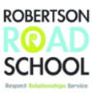  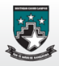  Personalised learning pathways for students in Kāhui Ako - Communities of Learning
 | Aim: Enable greater numbers of Māori and Pasifika students (particularly boys) to enjoy and achieve educational success with the support of their families/whānau through increased cultural responsiveness by teachers.
 | Establishing - 2017 | Developing - 2018 | Embedding - 2019 | Fully Functioning - 2020
 | - Gather evidence from and to meet regularly across 2017-2020 with family/whānau via hui, fono, community gatherings on how partnerships in learning are developing in all schools in our Kāhui Ako:  - Engage in respectful working / learning focused relationships.  - Provide contexts for learning where first languages and heritage cultures are used for learning purposes.  - Establish language progressions for Te Reo, Samoan and Tongan in speaking, reading and writing.  - Use student achievement data in these languages to set annual achievable targets in writing and speaking.  - Engage with parents, families & communities to have shared understandings of how (when working together) we can raise student achievement through using students first language / heritage language  - Develop shared understanding within the Kāhui Ako about the use of first language / heritage language for learning purposes.  - Explore ways in which the aspirations of parents/whānau are being captured and used by teachers to support learning and then feeding back to families / whānau and students on how those aspirations are being met through the school’s ongoing reporting cycles.  - Using information from A-D above, each school sets annual goals that strengthen learning focused relationships with family/whānau and establish reporting cycles where evidence can be shared with families/whānau as to how these aspirations are being met.  - Receive PLD on Ka Hikitia, Pasifika Education Plan and Tātaiako: Cultural Competencies for Teachers of Māori Learners then create an action plan on ways to implement effective practices in all schools, commencing 2018. | - Kāhui Ako Leaders collect evidence in the ways teachers are valuing and integrating students’ culture into learning programmes, then create online blogs for teachers to share these effective practices. Teachers of targeted boys set one or two goals to implement, from the ideas posted in the blog that will strengthen their teaching practice and review the effectiveness of these goals with Kāhui Ako leaders.  - Teachers plan how they will integrate the use Te Reo Māori, Samoan and Tongan languages into the delivery of teaching and learning programmes and at other culturally appropriate occasions / events / settings.  - Teachers in our Bi-lingual units and/or language based classrooms share the pedagogy which underpins the delivery of a dual language curriculum and develop, where possible, a shared pedagogical approach across all bilingual classrooms in our Kāhui Ako. | Classroom practices / programmes and curriculum delivery plans clearly reflect expected actions that are required to be in place that reflect students’ identity, language and culture / cultural locatedness.  - Actively participate in Kāhui Ako and/or school workshops based around cultural locatedness, then integrate that learning into daily teaching practices and review the effectiveness of these goals with Kāhui Ako leaders.  - Teachers in Bi-lingual units and/or language based classrooms come together to moderate samples of boys’ work in writing before making Overall Teacher Judgements. | - All students’ are achieving success in learning goals and reaching their potential in ways that support and reflect their family aspirations, cultural values and perspectives.  - Students, particularly boys, are included in relevant aspects of consultation around curriculum delivery, especially writing overviews and report that they find all the curriculum engaging, exciting, interesting and that they can see their progress in learning.  - Parents/whānau are well-engaged as partners in learning in all aspects of their children’s programmes. Parents / whānau report that they feel relaxed, accepted, respected within the community and that they have a valuable part to play in ensuring their kids success  - Teachers will use Tātaiako: Cultural Competencies for Teachers of Māori Learners and will place these competencies alongside their Practicing Teachers Criteria with supporting evidence of how these are being met.  - Māori & Pasifika content and language is clearly evident and infused in ways that are appropriate for local whānau; good links are made between curriculum context and the cultures and backgrounds of our boys who are below the National Standards/NCEA levels.  - Our Kāhui Ako Bi-lingual Units and/or classroom based language programmes are clearly understood by all our Col stakeholders and are acknowledged as authentic language learning pathways.

Appendix 1: Data analysis and School Level targets

Achievement Challenge: Number of Students in Years 1-8 ‘At or Above’ National Standards in Writing by School
 | Total Students | Baseline (2016) |  | Target (2020) |  | Required Shift
School: Name |  | Number | % of Total | Number | % of Total | Number | %points
Koru School | 524 | 273 | 52% | 427 | 81% | 154 | 29%
Mangere East School | 533 | 386 | 72% | 500 | 94% | 114 | 21%
Robertson Road School | 559 | 356 | 64% | 485 | 87% | 129 | 23%
Southern Cross Campus | 745 | 423 | 57% | 600 | 81% | 177 | 24%
Sutton Park School | 417 | 206 | 49% | 350 | 84% | 144 | 35%
Kāhui Ako Total | 2,778 | 1,644 | 59% | 2,362 | 85% | 718 | 26%

Achievement Challenge: Number of Students in Years 1-8 ‘At or Above’ National Standards in Mathematics by School
 | Total Students | Baseline (2016) |  | Target (2020) |  | Required Shift
School: Name |  | Number | % of Total | Number | % of Total | Number | %points
Koru School | 524 | 303 | 58% | 436 | 83% | 133 | 25%
Mangere East School | 533 | 395 | 74% | 500 | 94% | 105 | 20%
Robertson Road School | 559 | 308 | 55% | 455 | 81% | 147 | 26%
Southern Cross Campus | 745 | 401 | 54% | 596 | 80% | 195 | 26%
Sutton Park School | 417 | 293 | 70% | 375 | 90% | 82 | 20%
Kāhui Ako Total | 2,778 | 1,700 | 61% | 2,362 | 85% | 662 | 24%

Achievement Challenge: Number of Students in Years 9 – 10 ‘At or Above’ National Standards in Writing by School
 | Total Students | Baseline (2016) |  | Target (2020) |  | Required Shift
School: Name |  | Number | % of Total | Number | % of Total | Number | %points
Southern Cross Campus | 330 | 138 | 42% | 263 | 80% | 125 | 38%
Kāhui Ako Total | 330 | 138 | 42% | 263 | 80% | 125 | 38%

Achievement Challenge: Number of Students Achieving NCEA L3 and UE
 | Total Students | Baseline (2016) |  | Target (2020) |  | Required Shift
School: Southern Cross Campus |  | Number | % of Total | Number | % of Total | Number | %points
NCEA Level 3 | 158 | 107 | 68% | 134 | 85% | 27 | 17%
University Entrance | 158 | 32 | 20% | 63 | 40% | 31 | 20%

